COUNCIL ASSESSMENT REPORT

Panel Reference | PPSSNH-289
DA Number | DA442/21
LGA | North Sydney
Proposed Development | Construction of three residential flat buildings and nine townhouses, with three levels of basement parking
Street Address | 27-57 Falcon Street, Crows Nest
Applicant/Owner | Crows Nest Developments Pty Ltd
Date of DA lodgement | 16 December 2021
Number of Submissions | 7
Recommendation | Approval
Regional Development Criteria (Schedule 4A of the EP&A Act) | Capital Investment Value (CIV) of greater than $30 million
List of all relevant s4.55(1)(a) matters | North Sydney LEP 2013  - Zoning – R4 High Density Residential  SEPP (Resilience and Hazards) 2021  SEPP (Biodiversity and Conservation) 2021  North Sydney DCP 2013
List all documents submitted with this report for the Panel’s consideration | Architectural Plans  Landscape Plans  Architectural Design Report (SEPP 65/ADG)  Conditions of consent
Report prepared by | George Youhanna, Executive Planner - North Sydney Council
Report date | 1 June 2022

Summary of s4.15 matters  Have all recommendations in relation to relevant s4.15 matters been summarised in the Executive Summary of the assessment report? | Yes
Legislative clauses requiring consent authority satisfaction  Have relevant clauses in all applicable environmental planning instruments where the consent authority must be satisfied about a particular matter been listed, and relevant recommendations summarized, in the Executive Summary of the assessment report?  e.g. Clause 4.6(4) of the relevant LEP | Yes
Clause 4.6 Exceptions to development standards  If a written request for a contravention to a development standard (clause 4.6 of the LEP) has been received, has it been attached to the assessment report? | N.A.
Special Infrastructure Contributions  Does the DA require Special Infrastructure Contributions conditions (S94EF)?  Note: Certain DAs in the Western Sydney Growth Areas Special Contributions Area may require specific Special Infrastructure Contributions (SIC) conditions | N.A.
Conditions  Have draft conditions been provided to the applicant for comment?  Note: in order to reduce delays in determinations, the Panel prefer that draft conditions, notwithstanding Council’s recommendation, be provided to the applicant to enable any comments to be considered as part of the assessment report | Yes

EXECUTIVE SUMMARY

This development application seeks approval to construct three residential flat buildings and nine townhouses at 27-57 Falcon Street, Crows Nest. The DA seeks approval for:

- Site preparation works (demolition has already occurred, approved under separate consent)
- Construction of three residential flat buildings and nine townhouses, with a maximum height of 21 metres, and 8,032m2 of gross floor area (GFA), including:
  - 7,845m2 of residential gross floor area.
  - 187m2 of non-residential gross floor area.
  - 74 apartments and 9 townhouses.
- Construction of three basement levels with 94 car parking spaces, 95 bicycle parking spaces and 9 motorcycle spaces.
- Public domain, landscaping and associated infrastructure works.

Council’s notification of the proposal attracted seven (7) submissions raising concern with regard to setbacks, non-compliances, misleading plans, pedestrian safety, traffic impacts, footpath width, laneway safety, construction traffic, road damage, increased traffic volume in laneways, traffic safety, building height, exceedance of 10 metre height limit, precedent, unit mix, lack of parking, development not consistent with earlier scheme.

The proposed development has been assessed with respect to the objects and relevant Sections of the EP&A Act, as well as the objectives, merit based provisions, development standards and prescriptive controls of various State Environmental Planning Policies, the North Sydney Local Environmental Plan 2013 and the North Sydney Development Control Plan 2013. Other plans and policies were also considered such as the North Sydney Section 7.11 Contributions Plan.

The development complies with all relevant development standards in North Sydney LEP.

Council’s Design Excellence Panel has considered the proposal and the Panel’s advice has largely been adopted in the revised development.

At the time of finalisation of this report, concurrence is yet to be received from Sydney Metro and TfNSW, however it is anticipated that concurrence will be received prior to the determination meeting date of 15 June 2022. In the event that concurrence is not received by 15 June 2022, the determination will need to be deferred. The application is being reported to the Sydney North Planning Panel on this basis (ie, the reasonable expectation that concurrence will be received prior to the determination meeting), rather than deferring the determination meeting at this time, and potentially delaying determination of the application unnecessarily.

Following assessment of the development application, it is recommended that, subject to concurrence being provided by Sydney Metro and TfNSW, the Panel grant consent to the development, subject to conditions.

- DESCRIPTION OF PROPOSAL

This development application seeks approval to construct three residential flat buildings and nine townhouses at 27-57 Falcon Street, Crows Nest. The DA seeks approval for:

- Site preparation works (demolition has already occurred, approved under separate consent)
- Construction of three residential flat buildings and nine townhouses, with a maximum height of 21 metres, and 8,032m2 of gross floor area (GFA), including:
  - 7,845m2 of residential gross floor area.
  - 187m2 of non-residential gross floor area.
  - 74 apartments and nine townhouses.
- Construction of two basement levels with 94 car parking spaces, 95 bicycle parking spaces and 9 motorcycle spaces.
- Public domain, landscaping and associated infrastructure works.

Photomontage – Falcon Street/Alexander Lane corner (Building A):
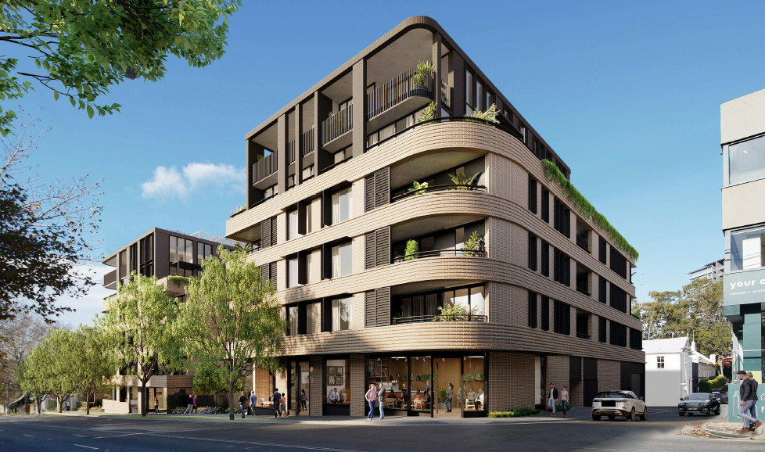

Photomontage – Hayberry Lane (Building D):
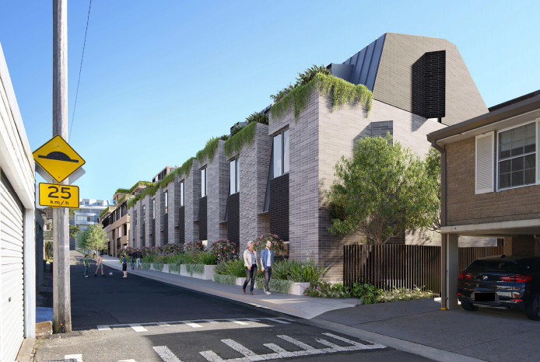

Proposed Massing:
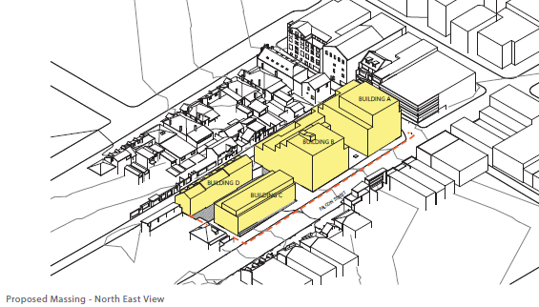
Falcon Street Elevation:
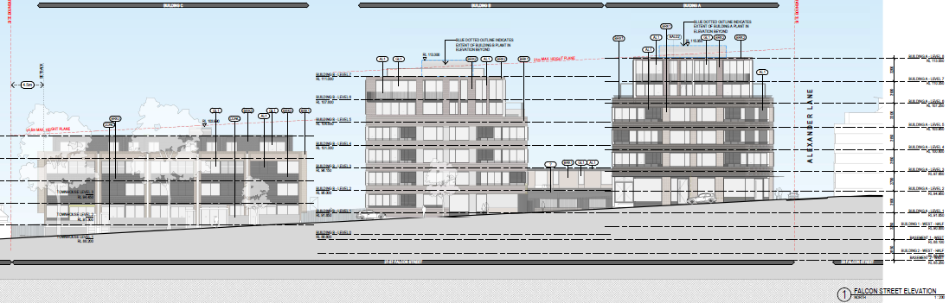

Hayberry Lane Elevation:
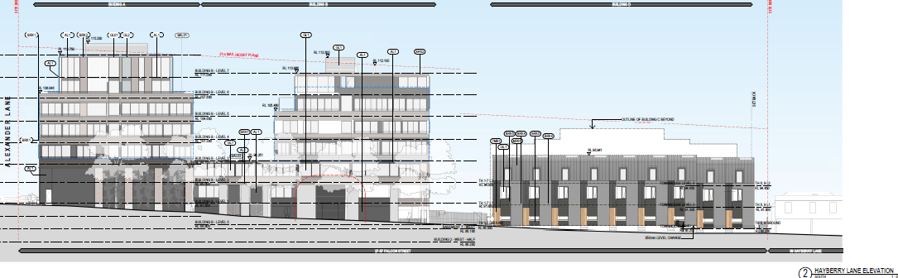

- STATUTORY CONTROLS

North Sydney LEP 2013
- Zoning – R4 High Density Residential
- Item of Heritage – No
- In Vicinity of Item of Heritage – No
- Conservation Area – No
Environmental Planning & Assessment Act 1979
SEPP (Resilience and Hazards) 2021
SEPP (Transport and Infrastructure) 2021
SEPP 65 – Design Quality of Residential Apartment Development

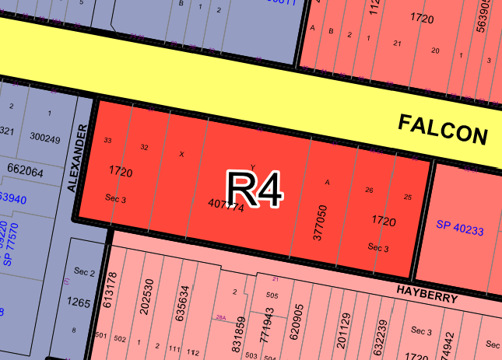

2.1 POLICY CONTROLS

North Sydney DCP 2013

- CONSENT AUTHORITY

As this proposal has a Capital Investment Value (CIV) of greater than $30 million the consent authority for purpose of determination of the development application is the Sydney North Planning Panel.

- DESCRIPTION OF SITE AND LOCALITY

The site comprises seven allotments and is located on Falcon Street, with frontages to Hayberry Lane and Alexander Lane. The site is known as 27-57 Falcon Street, Crows Nest.
The site has an area of 4,325m² and is rectangular in shape. The site falls approximately 6.48 metres from the corner of Alexander Lane and Falcon Street down to the southern-eastern corner.

The site is located on the eastern side of the Crows Nest town centre and is approximately 1.3 kilometres north of the North Sydney CBD and 1 kilometre southwest of the St Leonards Town Centre. The Crows Nest town centre is characterised by a mix of residential apartments, commercial and retail uses, and restaurants.

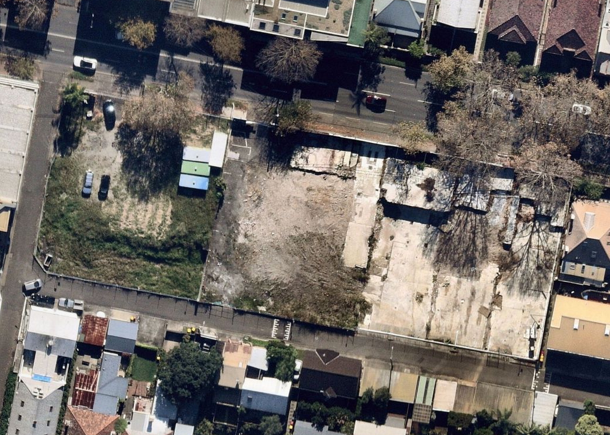

- BACKGROUND

26/11/21 – Site specific amendments to NSLEP 2013 gazetted, including rezoning the site to R4 High Density Residential, increasing the height limit to part 21m and part 14.5m, maximum FSR of 1.85:1, and retention of retail as a permissible use, inter alia. Site specific provisions in NSDCP 2013 also came into effect upon gazettal of the LEP amendments, on 26/11/21.
16/12/21 – DA442/21 lodged.
14/1/22 – DA442/21 advertised for 14 days.
18/5/22 – Amended plans and documents downloaded from portal, including minor amendments addressing DEP comments.

- REFERRALS

6.1 Building

Council’s Senior Building Surveyor provided the following comments:

The Development Application seeks approval for the construction of three residential flat buildings and nine townhouses, including two basement levels.

The building will be classified by the NCC BCA 2019 as a 2, 6, 7a & 7b building of Type A construction.

The development application is supported by a BCA Compliance Assessment Report dated November 2021 prepared by Steve Watson & Partners. The BCA Report concludes that the proposed design can comply with the requirements of the NCC BCA via a combination of satisfying the Deemed to Satisfy provisions of the BCA and use of Performance based and Fire Engineering Solutions. Page 3 of the BCA Report identifies the non-compliances to be addressed by Performance based and Fire Engineering Solutions.

The application is further supported by a Fire Engineering Statement dated 12 November 2021 prepared by CORE Engineering Group which concludes that the proposed design and use of Performance based Solutions will have immaterial impact on the buildings design.

Acceptance of any Performance based Solution is a matter for an appropriately accredited building surveyor during Construction Certificate assessment.

The application contains a Statement of Compliance Access for People with a Disability dated 25 October 2021 prepared by Accessible Building Solutions which concludes that the proposed design can comply with the NCC BCA.

A detailed assessment of compliance with the Building Code of Australia 2019 will be undertaken by an appropriately accredited certifier at the Construction Certificate Stage of the proposed development. Additionally, a Fire Safety Schedule is to be prepared by the certifier and accompany the Construction Certificate.

As the buildings are new buildings, construction in accordance with the NCC BCA 2019 is required.

6.2 Engineering/Stormwater Drainage

Council’s Development Engineer has assessed the proposed development and provided a number of conditions. Should the development application be approved, the imposition of a number of standard and site specific conditions relating to infrastructure works, damage bonds, excavation, dilapidation reports of adjoining properties, construction management plan, vehicular crossing requirements and stormwater management would be required.

Council’s Engineering Project Manager has provided the following comments:

The connection point shown on the plan is not an existing pit but the outlet for the building outlet. All junction pits are to be at the surface and not buried as per the plan. Drains modeling will be required to ensure that the proposed drainage layout will not adversely effect the current drainage system or any properties downstream. The existing converter from Alexander Lane is currently under design to be extended to join into the Hayberry Lane drainage system, these works will ideally take place before the new kerb alignment works.

6.3 Landscaping

Council’s Landscape Officer has raised no objections subject to conditions.

6.5 Environmental Health

Council’s Team Leader Environmental Health has raised no objections subject to conditions, including conditions requiring remediation of the site.

6.5 Waste Management

Council’s Waste Operations and Education Officer has provided the following comments:

The waste management facilities in this proposal are not acceptable for Council’s requirements. 1. The residential and commercial bins need a bin holding area for collection off the street and within 2 meters of the street alignment. The collection area needs to accommodate the minimum number of bins. Minimum residential bins required are 27 x 240L general waste and 48 x 240L recycling or equivalent. 2. Collection is once a week only 3. There needs to be functional bulky waste storage room separate from the garbage storage room. The proposed development must adhere to the NSC DCP 2013 Section 19 - Waste Minimisation and Management and Part B: Section 2 - Commercial and Mixed Use Development requirements. A temporary holding bay for collections must be provided of sufficient size to accommodate the required garbage and recycling bins as well as bulky waste material and located within 2 meters from the street boundary. Residential and Commercial garbage storage and chutes must be kept separate. Key access should be used for the garbage storage areas. Garbage compaction rate of no more than 2:1. The following standard conditions will apply to this proposed development: Condition C11 Condition C51 Condition I29. Some other mixed use development conditions may apply.

In addition, the townhouses need to have a bin collection area 2m from the kerb as well as a bulky waste storage area as per below.

Planning comment – Conditions of consent have been applied to address the identified issues.

6.6 Design Excellence Panel

Council’s Design Excellence Panel provided the following advice:

Principle 1: Context and local character
In relation to the potential through site link within Courtyard 2, it was considered that if open to the public, the through-site link may compromise the amenity and safety of the communal open space. If it is provided, secure fencing along the link should be set back from the pedestrian path and integrated into landscaping.

Any gate system should be easily fixed in an open position to allow a clear and inviting through site link should this be desired in the future. This also facilitates a timed approach for the link – fore example it could remain open during daylight hours.

Principle 2: Built form, scale and public domain/ urban design response
Additional transition space and visual privacy measures should be considered to the ground level of the Building D townhouses facing Hayberry Lane. The kitchen windows should be screened with landscaping or screens/batten shutters. Operable screens would allow the occupants to control privacy and enable an activated and passively surveyed streetscape.

The design should introduce a greater variety of street treatments to Building D (Hayberry Lane frontage) and courtyard wall/gate treatments (communal open space to north frontage).

12m building separation at Level 4 between Building B and C is not achieved, compromising privacy. This could be addressed with screens.

The proponent is encouraged to cater for differing needs for outdoor open space. Further development of informal or formal, play opportunities and a more varied landscape experience would be welcome.

Principle 3: Density
The proposed density is generally consistent with the North Sydney LEP and site specific DCP provisions drafted for this site.

Principle 4: Sustainability, building performance and adaptability
Applicant to clarify the nature of solar shading to east and west facades. The image on page 24 is unclear. Shading elements should be designed to be effective in protecting glazing from high and low altitude sun in summer.

Solar access is stated to be 69.87%, which virtually satisfies ADG, but in a development of this scale and on an open site, with some re-planning it is considered that this could be significantly improved.

Principle 5: Landscape Integration
In general, the massing and distribution of built form seems well considered: however more detailed landscape drawings are required as the image quality is too low to review the proposal thoroughly.

In relation to the façade treatment to Building A facing east towards the communal open space, the potential use of a green wall or vines should be considered

A site of this magnitude has the capacity to contribute to local habitat through careful endemic planting is significant. The Jacaranda trees proposed– speak to a recent past but here we have the opportunity to build on the richer legacy through the use of endemic trees and planting. Revised planting to encourage bird life and create habitat for local fauna would improve the proposal.

Principle 6: Building configuration, planning, and amenity
It appears the Building D townhouses have been excluded from the ADG assessment which if included may result in inadequate solar access to the overall development. The Panel is of the view that the ADG should apply to all residential components of three or more storeys unless adequate justification can be provided Alternatively the Low Rise Housing Diversity Design Guide 2020 could be applied to Building D.

It has been identified that some bedrooms are recessed 4-5m eg B105 resulting in poor amenity and a number of kitchens are too small and with inadequate joinery/counter length eg B108.

Some south facing balconies could be relocated to north facing Falcon St frontage eg. C402, C401.

Some balconies do not achieve minimum ADG sizes eg. A302 and all balconies should be modified to meet the minimum ADG area and dimensions.

Intrusive traffic noise from Falcon Street will need to be addressed in detail in order to demonstrate compliance with the required internal noise criteria, particularly with regard to operable windows.

In relation to waste management, clarification is required as to how bins will be transferred from the storage rooms to the collection area, either by ramp or lift and whether all waste is moved horizontally to the Building A basement and collected from Alexander Lane. Details of bin storage and collection for the terraces is also required.

Principle 7: Safety
The proposed Hayberry Lane Building D treatment would provide satisfactory safety for pedestrians with regard to CPTED principles, with casual surveillance of the laneway from the terraces. Street activation and passive surveillance could be enhanced to the Hayberry Lane façade of Block B with the introduction of another 2 storey dwelling connecting to the street of a similar layout to dwelling B107. The Falcon Street entry is improved with regard to safety and is satisfactory.

Principle 8: Housing diversity and social interaction
In relation communal facilities for Blocks A & B, an attractive enclosed communal area with good access to natural daylight should be provided, for use by residents in wet and windy weather conditions. It should receive good sunlight, and potentially roof-top location could be ideal. The external communal areas as proposed should be visually attractive, but much of their area are extensively overshadowed during winter.

Principle 9: Architectural expression and materiality
Additional detail is required in relation to the treatment of the elevations. Details such as brickwork, sunhoods, etc should be included in 1:20 sections through the façade.

Recommendations to Achieve Design Excellence
The Panel considers the design to be of good quality, and gives qualified support for the proposal, subject to resolution of the identified issues as detailed above under each Principle.

Comment – The application was amended in response to the DEP comments and the advice has largely been adopted in the revised design. The proposal is considered satisfactory with regard to the advice of the DEP.

7.1 External Referrals

Sydney Metro

Sydney Metro provided the following response, dated 21 March 2022, to a concurrence referral:

Sydney Metro refers to Development Application 442/21 (DA) submitted by Leigh Manser (Applicant) that has been referred to Sydney Metro via the NSW Planning Portal on 17 February 2022 in accordance with clause 2.98 of the State Environmental Planning Policy (Transport and Infrastructure) 2021 (previously clause 86 of the State Environmental Planning Policy [Infrastructure] 2007).

Transport for NSW (TfNSW) has delegated its rail authority functions in relation to the Sydney Metro – City & Southwest and Metro North West Line rail corridors to Sydney Metro. Therefore, Sydney Metro is the relevant rail authority for the Sydney Metro – City & Southwest rail corridor for the purpose of the Transport and Infrastructure SEPP.

Sydney Metro has reviewed the DA documents that were uploaded onto the NSW Planning Portal on 14 December 2021.

Following this review, Sydney Metro advises that it is not in a position to make a decision on the granting of concurrence until the additional information outlined below is provided for Sydney Metro’s further review:

a) An impact assessment including details of potential impacts of the development on the Sydney Metro rail corridor (1st and 2nd reserves) in accordance with the Sydney Metro Underground Corridor Protection Technical Guideline (available at sydneymetro.info).
b) An electrolysis report providing an assessment of the electrolysis risks at the location of the proposed development in accordance with the Sydney Metro Underground Corridor Protection Technical Guideline (available at sydneymetro.info).
c) A geotechnical and structural report/drawings including details of potential impacts of the development on the rail corridor and/or infrastructure.
d) A construction methodology with details of the structural support during excavation and construction.
e) Cross sectional drawings showing ground surface, rail tracks, sub soil profile, proposed basement excavation and structural design of sub ground support adjacent to the rail corridor. All measurements must be verified by a registered surveyor.
f) A detailed survey plan showing the relationship of the proposed development with respect to the rail corridor and rail infrastructure.

In order to determine the corridor protection zones, you will need the Sydney Metro tunnel alignment and the location of the substratum:

• Sydney Metro infrastructure information: please contact the Sydney Metro team via SydneyMetroCorridorProtection@transport.nsw.gov.au.
• Stratum information can be obtained through:

1. The owners who were notified of the location of the stratum as part of the acquisition process.
2. The survey plans of acquisition have been registered with Land Registry Services, NSW.
3. Conducting a Dial Before You Dig search.

Sydney Metro requests that the Additional Information be provided to Council by no later than 21 days of the date of this letter, being 21 March 2022. If the Additional Information is not provided to Council by this date, Sydney Metro may determine not to provide its concurrence to the DA.

This request is made in accordance with section 52 of the Environmental Planning and Assessment Regulation 2021.

Council is requested to forward this request for the Additional Information to the Applicant and Sydney Metro recommends that the Applicant consult with Sydney Metro before submitting the Additional Information to Council.

Sydney Metro requests that the Additional Information be forwarded to SydneyMetroCorridorProtection@transport.nsw.gov.au and uploaded to the NSW Planning Portal to enable Sydney Metro to undertake the required internal review as quickly as possible and within the required statutory timeframe.

Sydney Metro also notes that this letter should immediately ‘stop-the-clock’ on the assessment of the DA, until such time as the Additional Information is provided.

Subject to the outcome of Sydney Metro’s review of the Additional Information, further additional information may be required before Sydney Metro can determine whether to grant concurrence to the DA.

Comment – The applicant advised Council that detailed consultation had taken place with Sydney Metro prior to lodgement of the DA. A detailed response was subsequently prepared by the applicant and submitted to Sydney Metro. On 27 May 2022, Sydney Metro advised that all matters had been satisfactorily resolved, with the exception of item c) above.

The applicant has provided a further response to Sydney Metro and as at the time of writing this report, is awaiting confirmation that the submitted information is satisfactory.

It is anticipated that given the nature of the remaining information sought by Sydney Metro, concurrence may be provided prior to the determination meeting, and any conditions of consent required by Sydney Metro can be included in the determination of the development application by the Panel.

In the event that concurrence is not received prior to the determination meeting date of 15 June 2022, the matter will need to be deferred.

TfNSW:

TfNSW provided the following response to a concurrence referral under clause 101 of SEPP (Infrastructure) 2007:

TfNSW has reviewed the submitted information and cannot provide concurrence under section 138 of the Roads Act, 1993 for the following reason:

1. Alexander Lane is currently a one-way road with a proposal to convert the section between Falcon Street and the driveway access to two-way operation. The following information shall be submitted:
• Detailed plans showing signage including turning restrictions to ensure a left in/left out only arrangement at the intersection of Falcon Street and Alexander Lane.
• Detailed plans including appropriate measures to ban right turn movements from Falcon St into Alexander Lane
• Swept paths demonstrating movements on Falcon St and the laneway
• Detailed plans showing lane widths and lane allocations

Upon receiving amended plans, addressing the above, TfNSW will review and provide a response accordingly

Comment - A formal response including detailed plans addressing all of the identified concerns was prepared by JMT Consulting Engineers on 12 April 2022, following informal discussions with TfNSW. However, the formal response was not provided to TfNSW until 30 May 2022, due to an issue with the NSW Planning Portal.

At the time of preparation of this report, concurrence from TfNSW had not been provided.

Despite this it is anticipated that given the uncontroversial nature of the matters raised by TfNSW, concurrence will be provided prior to the determination meeting, and any conditions of consent required by TfNSW can be included in the determination of the development application by the Panel.

In the event that concurrence is not received prior to the determination meeting date of 15 June 2022, the matter will need to be deferred.

Sydney Water:

Thank you for notifying Sydney Water of DA 442/21 at 27 Falcon Street, Crows Nest, which proposes construction of three residential flat buildings and nine townhouses, with a maximum height of 21 metres, and 8,032m2 of gross floor area, two basement levels with 94 car parking spaces, 95 bicycle parking spaces and 9 motorcycle spaces and public domain, landscaping and associated infrastructure works. Sydney Water has reviewed the application based on the information supplied and provides the following comments to assist in planning the servicing needs of the proposed development.

Water Servicing
• Servicing requirements for this development have been provided within the Notice of Requirements issued to the proponent on 1 February 2022 pursuant to Sydney Water case number 196461. Requirements may extend to any further Notices of Requirements which may be issued under this case or any future cases as a part of the Section 73 application process.

Further advice and requirements for this proposal are in Attachment 1.

Attachment 1

Section 73 Compliance Certificate
A Section 73 Compliance Certificate under the Sydney Water Act 1994 must be obtained from Sydney Water.

The proponent is advised to make an early application for the certificate, as there may be water and wastewater pipes to be built that can take some time. This can also impact on other services and buildings, driveways or landscape designs.

Applications must be made through an authorised Water Servicing Coordinator. For help either visit www.sydneywater.com.au > Plumbing, building and developing > Developing > Land development or telephone 13 20 92.

Building Plan Approval
The approved plans must be submitted to the Sydney Water Tap in™ online service to determine whether the development will affect any Sydney Water sewer or water main, stormwater drains and/or easement, and if further requirements need to be met.

The Tap in™ service provides 24/7 access to a range of services, including:
• building plan approvals
• connection and disconnection approvals
• diagrams
• trade waste approvals
• pressure information
• water meter installations
• pressure boosting and pump approvals
• changes to an existing service or asset, e.g. relocating or moving an asset.

Sydney Water’s Tap in™ online service is available at: https://www.sydneywater.com.au/SW/plumbing-building-developing/building/sydney-water-tap-in/index.htm

Sydney Water recommends developers apply for Building Plan approval early as in some instances the initial assessment will identify that an Out of Scope Building Plan Approval will be required.

Out of Scope Building Plan Approval
Sydney Water will need to undertake a detailed review of building plans:
1. That affect or are likely to affect any of the following:
• Wastewater pipes larger than 300mm in size
• Pressure wastewater pipes
• Drinking water or recycled water pipes
• Our property boundary
• An easement in our favour
• Stormwater infrastructure within 10m of the property boundary.

2. Where the building plan includes:
• Construction of a retaining wall over, or within the zone of influence of our assets
• Excavation of a basement or building over, or adjacent to, one of our assets
• Dewatering – removing water from solid material or soil.

The detailed review is to ensure that:
• our assets will not be damaged during, or because of the construction of the development
• we can access our assets for operation and maintenance
• your building will be protected if we need to work on our assets in the future.

The developer will be required to pay Sydney Water for the costs associated with the detailed review.

Tree Planting
Certain tree species placed in close proximity to Sydney Water’s underground assets have the potential to inflict damage through invasive root penetration and soil destabilisation. Sydney Water requires that all proposed or removed trees and vegetation included within the proposal adhere to the specifications and requirements within Section 46 of the Sydney Water Act (1994) and Diagram 5 – Planting Trees within our Technical guidelines – Building over and adjacent to pipe assets. Please note these guidelines include more examples of potential activities impacting our assets which may also apply to your development.

If any tree planting proposed breaches our policy, Sydney Water may need to issue an order to remove every tree breaching the act, or directly remove every tree breaching the Act and bill the developer or Council for their removal.

Planning Comment:

Appropriate conditions will be applied.

Ausgrid

This letter is Ausgrid’s response under clause45(2) of the State Environmental Planning Policy (Infrastructure) 2007.

Ausgrid does not have any objections for the proposed development. The applicant/developer should note the following comments below regarding any proposal within the proximity of existing electrical network assets.

Overhead Powerlines
Safe work NSW Document – Work Near Overhead Powerlines: Code of Practice, outlines the minimum safety separation requirements between these mains/poles to structures within the development throughout the construction process. It is a statutory requirement that these distances be maintained throughout construction. Special consideration should be given to the positioning and operating of cranes and the location of any scaffolding.

The “as constructed” minimum clearances to the mains should also be considered. These distances are outlined in the Ausgrid Network Standard, NS220 Overhead Design Manual. This document can be sourced from Ausgrid’s website, www.ausgrid.com.au

It remains the responsibility of the developer and relevant contractors to verify and maintain these clearances onsite.

"Should the existing overhead mains require relocating due to the minimum safety clearances being compromised in either of the above scenarios, this relocation work is generally at the developers cost.

It is also the responsibility of the developer to ensure that the existing overhead mains have sufficient clearance from all types of vehicles that are expected be entering and leaving the site."

Underground Cables
Special care should also be taken to ensure that driveways and any other construction activities within the footpath area do not interfere with the existing cables in the footpath. Ausgrid cannot guarantee the depth of cables due to possible changes in ground levels from previous activities after the cables were installed. Hence it is recommended that the developer locate and record the depth of all known underground services prior to any excavation in the area.

Safework Australia – Excavation Code of Practice, and Ausgrid’s Network Standard NS156 outlines the minimum requirements for working around Ausgrid’s underground cables. Should ground anchors be required in the vicinity of the underground cables, the anchors must not be installed within 300mm of any cable, and the anchors must not pass over the top of any cable.

Planning Comment:

Suitable conditions have been applied.

- SUBMISSIONS

The application was notified in accordance with Council policy from 14 January 2022 until 28 January 2022. Seven (7) submissions were received.

The issues raised can be summarised as:
- excessive building height,
- setbacks
- non-compliances
- misleading plans
- pedestrian safety
- traffic impacts
- footpath width
- laneway safety
- construction traffic
- road damage
- increased traffic volume in laneways
- traffic safety
- exceedance of 10 metre height limit
- precedent
- unit mix
- lack of parking
- development not consistent with earlier scheme

The submissions received are available for the Panel’s review. It should be noted that the concerns raised in submissions broadly reflect those received during the planning proposal process.

- CONSIDERATION

The relevant matters for consideration under Section 4.15 of the Environmental Planning and Assessment Act 1979, are assessed under the following headings:

The application has been assessed against the relevant numeric controls in NSLEP 2013 and DCP 2013 as indicated in the following compliance tables. More detailed comments with regard to the particular issues are provided later in this report.
NSLEP 2013:
Maximum building height:
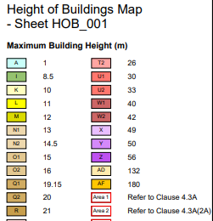 | 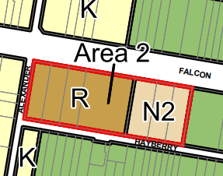

The maximum building height of development on the site under NSLEP 2013 is partly 21m and partly 14.5m, with an additional height allowance of up to 3m for lift overruns and plant as per clause 4.3A(2A).
Maximum FSR:
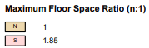 | 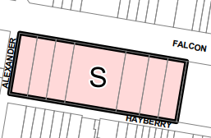

The maximum FSR of development on the site under NSLEP 2013 is 1.85:1.

8.1 Compliance Tables

NSLEP 2013 | Proposed | Control | Complies
Height (Cl. 4.3 and 4.3A(2A)) | 21.0m  14.5m  *(23.5m/15.7m including lift overruns and plant ) | 21.0m  14.5m
  YES*
FSR (Cl. 4.4) | 1.85:1 | 1.85:1
  YES
* (up to 3.0m exceedance for lift overruns and roof plant permitted under clause 4.3A(2A))

DCP 2013 Compliance Table

DEVELOPMENT CONTROL PLAN 2013 – Part B Section 1- Residential Development

 | complies |  |  | Comments
1.2 Social Amenity
Population Mix  Studio – 10-20%  1 bedroom – 25-35%  2 bedroom – 35-45%  3 bedroom+ - 10-20% | No |  |  | The proposed unit mix varies slightly from the required unit mix, however the proposal is consistent with the objectives of requirement and is considered satisfactory, providing 3% studio, 34% one bedroom units, 46% two bedroom units, and 17% three bedroom units.
Maintaining Residential Accommodation | Yes |  |  | The proposal significantly increases residential accommodation, providing 74 apartments and 9 townhouses
1.3 Environmental Criteria
Topography |  | Yes | The building design adequately responds to the topography of the site.
Views |  | Yes | The proposal will not have an adverse impact on any significant views available from surrounding properties.
Solar Access |  | Yes | The application includes shadow diagrams demonstrating the extent of overshadowing of properties in Alexander Lane and Hayberry Lane.  It is of direct relevance that the site specific DCP amendments include building envelope controls, including heights and setbacks, with one of the objectives being to maintain reasonable solar access to surrounding dwellings, “mindful of the need for renewal at the site”.  The proposed building envelopes are fully compliant and with regard to s.4.15(3A), the consent authority cannot require “more onerous standards”.  The proposed solar access to open space and dwellings in Alexander Lane and Hayberry Lane is satisfactory.
Acoustic Privacy |  | Yes | The proposal will not have an adverse impact on any surrounding property with regard to acoustic privacy or noise intrusion.
Visual Privacy |  | Yes | The proposal complies with the site specific DCP height and setback controls and one of the objectives of these controls is to ensure reasonable privacy is maintained to surrounding dwellings.  Further, the development is largely compliant with external ADG separation distances (setbacks), with the exception of Level 6 of Building A (the balcony to apartment A601) which is set back 6m from the centreline of Alexander Lane and is required to be set back 9m. The western edge of the subject balcony is partly landscaped with a planter box and a condition will be applied requiring privacy screening to a height of 1500mm to the remainder of the western side of the balcony, to ensure adequate separation in the event that the sites opposite are redeveloped:  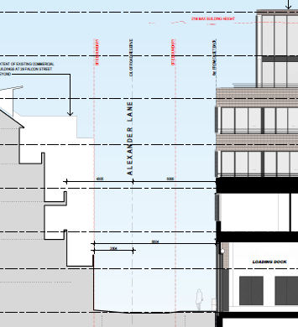  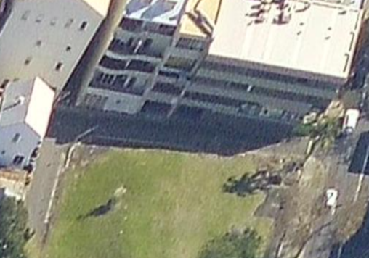  The proposal is satisfactory with regard to internal privacy, with compliant separation distances between dwellings, in part achieved through the use of non-habitable external wall treatments.  The proposal is satisfactory with regard to visual privacy.
1.4 Quality built form
Context | Yes |  |  | The building design is consistent with the site specific controls that apply to the site. The recently adopted controls support the provision of taller building elements being located towards the Falcon  Street frontage and Alexander Lane end of the site, then transitioning down to lower scale development to the east and south.  The proposal is in keeping with the desired future character of the area.
Laneways | Yes |  |  | The proposal is satisfactory with regard to the laneway provisions and treatment of Alexander and Hayberry Lane.
Siting | Yes |  |  | The proposed building is satisfactory with regard to the provisions of section 1.4.5 Siting.
Building Separation | Yes*  (* subject to privacy treatment of balcony to A601) |  |  | As discussed in relation Visual Privacy above, the development is largely compliant with external ADG separation distances (setbacks), with the exception of Level 6 of Building A (the balcony to apartment A601) which is set back 6m from the centreline of Alexander Lane and is required to be set back 9m.  As the western edge of the subject balcony is partly landscaped with a planter box, a condition requiring privacy screening remainder of the western side of the balcony will satisfactorily address potential privacy impacts as a result of the proposed 6m setback from the centreline of Alexander Lane. This requirement will provide for adequate privacy in the event of future redevelopment of No.25 Falcon Street to a similar height as the proposed development, should that occur.
Form Massing Scale | Yes |  |  | The proposed building form, massing and scale is considered to be satisfactory and consistent with the desired future character as set out in the specific LEP and DCP controls for the site.
Built Form Character | Yes |  |  | The subject site is zoned R4 with retail use permissible on the ground floor of Building A which is a mixed use building. Buildings B and C are residential flat buildings and building D comprises townhouses (multi-dwelling housing).  The proposed built form character is entirely consistent with the desired future character as provided for in the LEP and DCP and is satisfactory.
Dwelling Entry | Yes |  |  | The building entries are clearly distinguishable and well defined to all buildings.
Roofs | Yes |  |  | The proposed RFB flat roofs are appropriate with regard to the building typology, and the townhouses have pitched roofs which are also appropriate.
Colours and Materials | Yes |  |  | The proposed building colours and materials are satisfactory and suitable for the proposed building design.
Balconies - Apartments | Yes |  |  | All apartments are designed with a balcony or terrace.
Front Fences | Yes |  |  | The front fences are satisfactory.
1.5 Quality Urban Environment
High Quality Residential Accommodation | Yes |  |  | The apartments sizes, balconies and layouts meet the minimum ADG requirements. The development achieves 69.87% solar access and over 65% natural ventilation.  Substantial communal open space is provided at ground level (23.9% of the site area), in landscaped settings with good amenity.
Safety and Security | Yes |  |  | Satisfactory.
Vehicle Access and Parking | Yes |  |  | Vehicular access is provided via Alexander Lane as required. The DCP provides for a maximum of 94 spaces to be provided on site. The proposal includes 94 spaces.
Excavation | Yes |  |  | Suitable conditions will be applied, including in relation to potential site contamination.
Landscaping | Yes |  |  | The quality and design of the landscaping is satisfactory.
Front Gardens | Yes |  |  | The proposal includes adequate landscaping in the front garden areas.
Private and Communal Open Space | Yes |  |  | Suitable areas of communal open space are provided on site. Private open space has been provided for all dwellings.
Garbage Storage | Yes |  |  | See previous comments in relation Waste Management.
1.6 Efficient Use of Resources
Energy Efficiency | Yes |  |  | A valid BASIX Certificate has been provided.
Stormwater Management | Yes |  |  | Subject to conditions.

Part C – Area Character Statements
Section 3 - St Leonards/Crows Nest Planning Area

The subject site has site specific built form controls under NSDCP 2013, as follows:

DEVELOPMENT CONTROL PLAN 2013 – Part C Section 3 St Leonards/Crows Nest Planning Area

 | complies |  |  | Comments
3.2.5.1 Desired Future Character, Design Objectives and Key Principles:

Scale, character, transition in scale, residential amenity | Yes |  |  | The proposed development and built form are consistent with the building height, building setback and building density controls, resulting in a development that is entirely consistent with the desired future character as set out in the LEP and DCP provisions.
Mixed use typology | Yes |  |  | The proposal includes residential dwellings with ground floor retail.
Laneway widening | Yes |  |  | The proposal provides road widening to Alexander Lane and Hayberry Lane and a landscape treatment to Hayberry Lane.
Vehicular access from Alexander Lane/two way access to Falcon Street | Yes |  |  | Provided.
Through site link between Falcon Street and Hayberry Lane | No |  |  | The applicant has advised that the potential through site link is in close proximity to Alexander Street and would not provide significant benefits of permeability and connection, and would reduce the amount of communal open space in the development. It is agreed that a through site link would provide limited public benefit in terms of permeability and connectivity given the location and termination in Hayberry Lane.
3.2.5.2 Desired Built Form:

Building Height:
Building A – 6 storeys, stepping down to 3 storeys at Hayberry Lane | Yes |  |  | Maximum 6 storeys, stepping down to 3 storeys
Building B - 6 storeys, stepping down to 2-3 storeys at Hayberry Lane | Yes |  |  | Maximum 6 storeys, stepping down to 2-3 storeys
Building C – 4 storeys | Yes |  |  | 4 storey height.
Building D – 3 storeys, with 2 storeys to Hayberry Lane | Yes |  |  | 3 storey height, with 2 storey presentiation to Hayberry Lane
Street and Side Setbacks:
Falcon Street:  Building A – 0m  Building B – 0m  Building C – 2m |  | Yes  Yes  Yes | The proposed setbacks are satisfactory and compliant.
Hayberry Lane:  Building A – 3m  Building B – 3m  Building D – 1.5m |  | Yes  Yes  Yes | The proposed setbacks are satisfactory and compliant.
Side setbacks (56-63 Falcon St):  Building C – 4.5m  Building D – 1.5m |  | Yes  Yes | The proposed setbacks are satisfactory and compliant.
Alexander Lane:  Building A – 6m from centreline |  | Yes | The proposed setback is satisfactory and compliant.
3.2.5.3 Residential Apartment Building Design
SEPP 65 and ADG | Yes |  |  | The application is accompanied by a design verification statement and ADG compliance table, demonstrating that the development (Buildings A, B, C) is satisfactory with regard to the building and apartment design.  All apartments have good internal amenity and maintain reasonable amenity to surrounding development.  The development is satisfactory with regard to the ADG and the design quality principles in SEPP 65.
3.2.5.4 Site Coverage
Maximum site coverage 65% |  | Yes | The proposed site coverage of 61% is compliant.
3.2.5.5 Communal Open Space
Provide communal open space as per C-3.5 | Yes |  |  | Satisfactory with regard to provision and amenity, with a total area of 1012m².
3.2.5.6 Landscaped Area
Minimum 20% of site |  | Yes | The proposed 24.8% landscaped area is compliant.
3.2.5.7 Traffic, Access and Parking
Access from Alexander Lane, away from Falcon Street | Yes |  |  | Located on Alexander Lane at corner of Hayberry Lane
Alexander Lane to be widened | Yes |  |  | The lane will be widened as required.
On-site parking at maximum rates set out in Table C-3.1 (94 spaces) | Yes |  |  | 94 spaces provided.

Figure C-3.5: Site Layout Plan

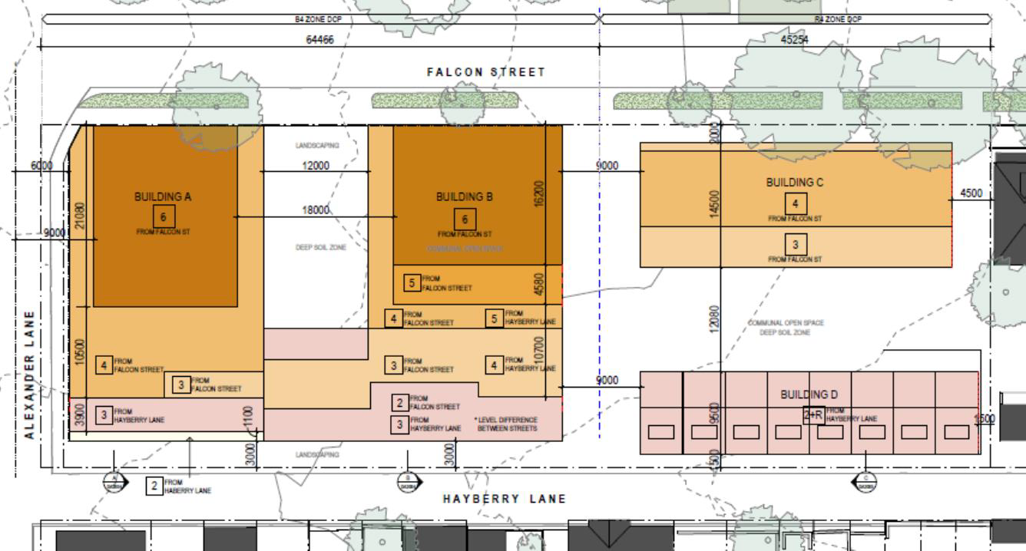

9.0 SEPP 65 - Design Quality of Residential Apartment Development

Principle 1 – Context and neighbourhood character
The proposed development is consistent with the context of surrounding development and the desired future character of the area, as set out in NSLEP 2013 and NSDCP 2013.

Principle 2 – Built form & scale
The proposed development complies with the height limit and FSR development standards, and complies with the setback requirements for the site. The proposed development is considered to be an appropriate form of development on the site, subject to conditions of consent.

Principle 3 – Density
The proposal has an FSR of 1.85:1 and the proposed density of development is satisfactory.

Principle 4 – Sustainability
The development is satisfactory with regard to sustainability and a valid BASIX Certificate was submitted with the application.

Principle 5 – Landscaping
The proposed area and quality of landscaping is considered satisfactory.

Principle 6 – Amenity
The proposal has been amended in relation to internal amenity and is considered satisfactory. The proposal has an acceptable impact on adjoining sites in relation to solar access, privacy, views and residential amenity.

Principle 7 – Safety
The proposal has been designed with regard to CPTED principles and is satisfactory with regard to safety, particularly to the laneways.

Principle 8 – Housing diversity and social interaction
The proposal includes a range of apartment sizes and is satisfactory with regard to housing diversity. The proposed communal open space is satisfactory.

Principle 9 – Aesthetics

The proposed building aesthetics have merit and the development is considered satisfactory in this regard.

Apartment Design Guide

The application includes an assessment of the proposal with regard to the ADG (Architectural Design Report prepared by Allen Jack + Cottier). The Architectural Design Report demonstrates compliance with the applicable Design Criteria, achieving the objectives of the provisions, particularly in relation to internal amenity, apartment configuration, solar access, natural ventilation, private open space, thermal comfort, the public domain interface, landscaping, streetscape, building design and communal open space. The proposal achieves the objectives of the ADG and is satisfactory in this regard.

- NORTH SYDNEY LEP 2013

10.1 - Permissibility within the zone

The site is zoned R4 High Density Residential, and is subject to Schedule 1 of NSLEP 2013 which also allows retail premises on the subject site.

The proposal, comprising residential flat buildings, multi-dwelling housing and retail premises, with ancillary parking, is permissible with consent in the R4 High Density Residential zone on the subject site.

10.2 - Zone R4 High Density Residential

Objectives of zone
- To provide for the housing needs of the community within a high density residential environment.
- To provide a variety of housing types within a high density residential environment.
- To enable other land uses that provide facilities or services to meet the day to day needs of residents.
- To encourage the development of sites for high density housing if such development does not compromise the amenity of the surrounding area or the natural or cultural heritage of the area.
- To ensure that a reasonably high level of residential amenity is achieved and maintained.

The proposal is a form of development that is specifically provided for, through site specific provisions.

The proposal is consistent with the objectives of the R4 zone.

10.3 - Height of buildings – Clause 4.3 and 4.3A(2A)

The Height of Building Map sets a height of building standard of RL 21.0m and 14.5m for the site.

Clause 4.3A(2A) Exceptions to Height of Buildings states:

(2A) Despite clause 4.3, the height of a building on land identified as “Area 2” on the Height of Buildings Map may exceed the maximum height shown for the land on that Map if—
(a) the height of the building does not exceed the maximum height by more than 3 metres, and
(b) the part of the building that exceeds the maximum height comprises the following—
(i) lift overruns and associated structures necessary to provide lift access to communal rooftop space,
(ii) balustrades or other safety barriers necessary to ensure the safe use of the space,
(iii) roof-top plant or equipment.

The maximum height of the proposed Buildings A and B is 21m to the top of the buildings and 23.5m including lift overruns and plant, in relation to that part of the site with a 21.0m height limit. The development complies with the 21.0m height limit for the subject part of the site.

The maximum height of the proposed Buildings C and D is 14.5m to the top of Building C and 15.7m including lift overruns and plant, in relation to that part of the site with a 14.5m height limit. Building D is three storeys in height and well below the 14.5m height limit. The development complies with the 14.5m height limit for the subject part of the site.

No contravention of the building height development standard is proposed and therefore there is no requirement for a clause 4.6 exception request.

10.4 – Floor Space Ratio - Clause 4.4

The development complies with the maximum FSR of 1.85:1 for the site and is satisfactory with regard to the proposed FSR.

11.0 – SEPP (Resilience and Hazards) 2021

The subject site has been considered with regard to potential contamination and remediation.

The application includes a Supplementary Site Investigation (Contamination) prepared by Douglas Partners, dated December 2021.

The report concludes that the site can be made suitable for the proposed residential use, subject to a Remediation Action Plan:

It is considered that the site can be made suitable for the proposed development subject to a remedial action plan (RAP), designed to reflect the results reported herein and the results of the additional work recommended above, and to address the overall contamination status of the site.

The RAP should incorporate (but not limited to) the following:

• UST decommission and removal, if required;
• Delineation investigation / asbestos assessment;
• Further groundwater / soil vapour monitoring (if required);
• Waste classification procedures;
• Material handling procedures;
• Odour management;
• Validation assessment; and
• Vapour barrier recommendations (if required).

Clause 4.6 of the SEPP RH states:

4.6 Contamination and remediation to be considered in determining development application
(1) A consent authority must not consent to the carrying out of any development on land unless—
(a) it has considered whether the land is contaminated, and
(b) if the land is contaminated, it is satisfied that the land is suitable in its contaminated state (or will be suitable, after remediation) for the purpose for which the development is proposed to be carried out, and
(c) if the land requires remediation to be made suitable for the purpose for which the development is proposed to be carried out, it is satisfied that the land will be remediated before the land is used for that purpose.

The site investigations carried out by the applicant demonstrate that the site will be suitable after remediation for the proposed development. Conditions of consent will require the land to be remediated before the land is used for the proposed residential development.

12.0 - SREP (Biodiversity and Conservation) 2021

The site is located within the catchment of Sydney Harbour and is subject to the provisions of SEPP BC. The site, however, is not located near the foreshore and will not be readily visible from the harbour. The application is satisfactory with regard to the aims and objectives of the SEPP.

13.0 - SECTION 7.11 CONTRIBUTIONS

There are no existing buildings on the site. The proposed development is subject section 7.11 contributions in accordance with Council’s S7.11 plan, with no allowance for existing development. The total contribution is calculated at $1,353,351.54.

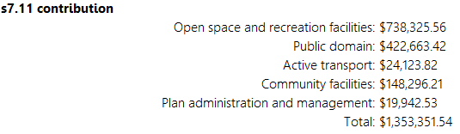

14.0 - DESIGN & MATERIALS

The design and materials of the buildings have been assessed as being of high quality and are acceptable.

15.0 - ALL LIKELY IMPACTS OF THE DEVELOPMENT

All likely impacts of the proposed development have been considered within the context of this report.

ENVIRONMENTAL APPRAISAL CONSIDERED

1. Statutory Controls Yes

2. Policy Controls Yes

3. Design in relation to existing building and Yes
natural environment

4. Landscaping/Open Space Provision Yes

5. Traffic generation and Carparking provision Yes

6. Loading and Servicing Facilities Yes

7. Physical relationship to and impact upon adjoining Yes
development (Views, privacy, overshadowing, etc.)

8. Site Management Issues Yes

9. All relevant S4.15 considerations of Yes
Environmental Planning and Assessment (Amendment) Act 1979

16.0 – Submissions

Seven (7) submissions were received by Council.

Relevant matters raised that have not been addressed previously in this report are discussed below:

Building D setback to Hayberry Lane was proposed to be 2m, not 1.5m; originally 8 townhouses not 9; proposal differs from the development shown at Community Information sessions (in 2019); pedestrian safety; inconsistent with setback provisions in 1.4.6 of DCP

Comment – As a result of the planning proposal process and consideration of the site specific DCP provisions, the adopted setback provision in NSDCP 2013 is for a 1.5m setback including a footpath, which is satisfactory for pedestrian safety and traffic movements and an improvement on the pre-development site conditions. The site specific DCP provisions in Part C prevail to the extent of any inconsistency with Part B provisions.

Potential damage to infrastructure beneath laneway from construction vehicles

Comment – Suitable conditions of consent have been applied in relation to construction impacts, including construction vehicles.

Traffic impacts of development in laneways, including Bernard Lane

Comment – The site specific DCP requires widening of Alexander Lane and Hayberry Lane, inter alia, to improve traffic conditions, as well as Alexander Lane being modified to accommodate two way traffic. The proposed parking provision of 94 spaces complies with the site specific DCP provisions and the carpark entrance is via Alexander Lane. The proximity of the site to excellent public transport services was a consideration during the site specific DCP review. The proposal is satisfactory in this regard.

17.0 – Conclusion and Reasons

The proposed development has been assessed with respect to the objects and relevant Sections of the EP&A Act, as well as the objectives, merit based considerations, development standards and prescriptive controls of various SEPPs, the North Sydney Local Environmental Plan 2013 and the North Sydney Development Control Plan 2013. The proposed development is considered satisfactory with regard to the above considerations, subject to conditions of consent.

The Council’s notification of the proposal attracted seven submissions. The concerns raised have been considered and addressed and do not warrant refusal or modification of the proposal.

The proposed development is entirely consistent with the form of development anticipated by the Planning Proposal process and provided for in the site specific LEP and DCP provisions.

Following assessment of the development application, the development is recommended for approval, subject to conditions.

RECOMMENDATION

PURSUANT TO SECTION 4.16 OF ENVIRONMENTAL PLANNING AND ASSESSMENT ACT 1979 (AS AMENDED)

THAT the Sydney North Planning Panel as the consent authority, subject to concurrence being provided by Sydney Metro and TfNSW, grant consent to PPSSNH-289, Development Application No.442/21 subject to conditions of consent (separate document).

George Youhanna Stephen Beattie
EXECUTIVE PLANNER MANAGER DEVELOPMENT SERVICES

